**US Stocks Margin Requirements**

For residents of the United States trading stocks:

* Rules-based margin
* Portfolio margin

The complete margin requirement details are listed in the sections below.

* **Long Position**

|  |  |  |
| --- | --- | --- |
| Margin | | |
| Initial Margin | 25%1 * Stock Value (minimum of USD 2,000 or 100% of the purchase price, whichever is less) |  |
| Maintenance Margin | 25% * Stock Value |  |
| Reg T End of Day Initial Margin | 50% * Stock Value |  |
| Cash or IRA Cash | 100% * Stock Value |  |
| IRA Margin | Same as Cash |  |

* **Short Positions**

|  |  |  |
| --- | --- | --- |
| Margin | | |
| Initial Margin | 30%2 * Market Value of Stock, if Stock Value > USD 16.67 per share USD 5.00 per share, if Stock Value < USD 16.67 and > USD 5.00 100% of Market Value of Stock, if Stock Value < USD 5.00 USD 2.50 per share, if Stock Value <= USD 2.50 |  |
| Maintenance Margin | Same as Initial Margin |  |
| Reg T End of Day Initial Margin | Same as Reg T End of Day for Long Positions. |  |
| Cash or IRA Cash | N/A |  |
| IRA Margin | Same as Cash |  |

Source: <https://www.interactivebrokers.com/en/trading/margin-stocks.php?hm=us&ex=us&rgt=1&rsk=0&pm=1&rst=101004110808>

**The two accounts Explained:**

For decades margin requirements for securities (stocks, options and single stock futures) accounts have been calculated under a Reg T rules-based policy. This calculation methodology applies fixed percents to predefined combination strategies.

With Portfolio Margin, margin requirements are determined using a "risk-based" pricing model that calculates the largest potential loss of all positions in a product class or group across a range of underlying prices and volatilities. This model, known as the Theoretical Intermarket Margining System ("TIMS"), is applied each night to U.S. stocks, OCC stock and index options and U.S. single stock futures positions by the federally-chartered Options Clearing Corporation("OCC") and is disseminated by the OCC to participating brokerage firms each night. The minimum margin requirement in a Portfolio Margin account is static during the day because the OCC only disseminates the TIMS parameter requirements once per day.

**1. Reg T Margin Account (Standard Retail Account)**

* **Leverage Limit:**  
  Up to **2:1** for equities (you can borrow up to your own equity to buy double the amount).
* **Initial Margin Requirement:**  
  Typically **50%** to open a position (you must fund half of the trade).
* **Maintenance Margin Requirement:**  
  Usually **25%** of the current market value (i.e., equity must remain at ≥ 25% of position size).
* **Margin Calls:**  
  Triggered **below 25%** equity-to-asset ratio. IBKR may liquidate positions to restore compliance.

**2. Portfolio Margin Account (PM)**

* **Leverage Limit:**  
  Varies depending on **asset risk**, **volatility**, and **market conditions**.  
  You may access up to **6.67x** leverage in very **low-volatility portfolios** like index ETFs (e.g., SPY, VTI).  
  Realistic **average leverage**: **3x–4x** for diversified portfolios.
* **Initial & Maintenance Margin:**  
  Calculated using a **risk-based model** (TIMS/SPAN).  
  Maintenance margin could be as low as **15%** (and even lower in certain cases for very stable assets).
* **Margin Calls:**  
  Triggered **below the risk-adjusted requirement**, not a fixed percentage.  
  Margin requirements are **continuously recalculated** throughout the day based on real-time portfolio risk.
* **Eligibility Requirements:**
  + Minimum equity: **$110,000+**
  + Approval by IBKR
  + Must be classified as a **sophisticated investor**

NOTE: IBKR does not provide historical data on their initial and maintenance margin. For simulation of past data, we shall build ours. Then at the moment, we can build an algorithm/code/app to be capturing their current initial and maintenance margin that you can always use in the future.

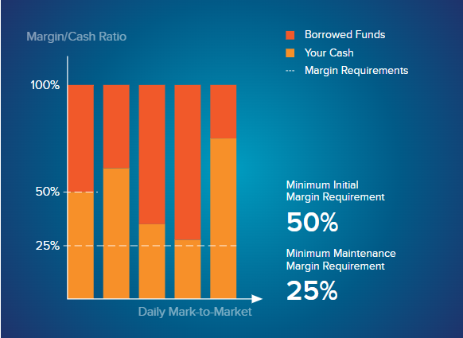

Reg-T; Rule-based margin from regulator.

*Source:* [*https://www.interactivebrokers.com/en/trading/margin-education.php*](https://www.interactivebrokers.com/en/trading/margin-education.php)

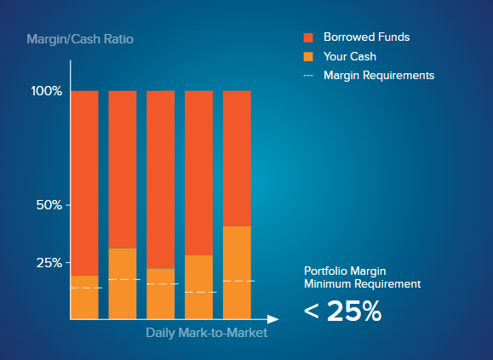

Portfolio Margin Accounts: Risk-based Margin

For futures, margin requirements are set by the listing exchange.  
For equities, margin requirements are set by the **broker**.

Which could be a function of liquidity, market capitalization, how concentrated the positions may be in a specific sector, How easy it is to sell the stock (see NVDA and TSLA for example), volatility, and other factors.

**Stocks (Equities)**

* **Who sets your cushion?** Your **broker** (e.g. Interactive Brokers, Robinhood, etc.).
* **Why does the broker decide?** They’re taking on risk when they lend you money to buy shares—so they tailor the rules based on:
  + **Liquidity:** How easy it is to buy or sell the stock quickly.
  + **Market cap:** Bigger, more established companies are usually “safer.”
  + **Concentration risk:** If you own a huge chunk of your portfolio in one sector (say tech), your broker might ask for more cushion.
  + **Other factors:** Volatility, regulatory rules, your own trading history, etc.
* **Result:** Two brokers might set different margin requirements on the exact same stock.

**Proposed Tools for development**

* Margin calculator + Simulation of over time portfolio performance and the varying risk-based margin.
* Interactive brokers Margin calculator: <https://www.interactivebrokers.com/en/trading/margin-calculator.php>
* Interest charged on margin loans simulations. It is charged based on a benchmark rate + tiers. Source <https://www.interactivebrokers.com/en/accounts/fees/interestCharged-Examples.php>
* Interest rate on margin loans calculator: <https://www.interactivebrokers.com/en/trading/margin-rates.php>
* Toggle between rule-based margin simulation and Risk based margin simulation(Reg T and portfolio Margin)
* Simulate slippage?
* Allow app to add more data of stocks and ETFs.

**FEATURES OF THE PROPOSED TOOL: "MARGINMASTER BACKTESTER"**

**1. Margin Calculator**

* **Functionality**: Calculates initial and maintenance margin requirements for any given position based on the account type (Reg T or Portfolio Margin).
  + **Reg T**: Fixed 50% initial margin, 25% maintenance margin for stocks/ETFs.
  + **Portfolio Margin**: Dynamic 10–50% initial/maintenance for SPY/VTI, *adjustable based on volatility (e.g., 20% during 2020 crash).*
* **Inputs**:
  + Position value (e.g., $1,000,000 SPY).
  + Leverage level (e.g., 5x).
  + Account type (Reg T or Portfolio Margin).
  + Volatility adjustment (optional, for Portfolio Margin).
* **Outputs**:
  + Initial margin requirement (e.g., $10,000 for 5x leverage under Portfolio Margin).
  + Maintenance margin requirement (e.g., $7,500 for $50,000 position at 15%).
  + Equity needed to avoid liquidation.

**2. Portfolio Performance Simulation Over Time**

* **Functionality**: Simulates the portfolio’s value, equity, and margin requirements daily over 2013–2025, incorporating:
  + **Price Changes**: Daily SPY/VTI price movements (from Yahoo Finance).
  + **Dividend Reinvestment**: Quarterly dividends (~1.5% annual yield), reinvested to increase equity.
  + **Margin Interest**: Daily interest on the margin loan (e.g., 5.33% in 2025, 1–3% in 2013–2019).
  + **Drawdowns**: Tracks maximum drawdowns (e.g., 2020: 34% SPY drop) to identify liquidation risks.
* **Outputs**:
  + Time series of portfolio value, equity, and leverage.
  + Key metrics: annualized returns, volatility, Sharpe ratio, max drawdown.
  + Liquidation events: Dates when equity falls below maintenance margin.

**3. Toggle Between Rule-Based (Reg T) and Risk-Based (Portfolio Margin) Simulations**

* **Functionality**: Allows switching between margin methodologies to compare outcomes.
  + **Reg T**:
    - 50% initial margin (2x leverage max).
    - 25% maintenance margin.
    - Liquidation when equity < 25% of portfolio value.
  + **Portfolio Margin**:
    - 15–20% initial/maintenance for SPY/VTI.
    - Dynamic adjustments (e.g., 20% maintenance during volatile periods like 2020).
    - Liquidation when equity < 15% (or adjusted threshold).
* **Feature**: A toggle button or command-line flag to switch modes, recalculating all metrics and liquidation points.

**4. Simulate Slippage**

* **Functionality**: Models slippage during liquidations, reflecting real-world market impact.
  + **Slippage Model**: Assumes a percentage price impact (e.g., 0.1–0.5%) when IBKR liquidates positions to restore margin compliance.
  + **Implementation**: When a liquidation is triggered (equity < maintenance margin), reduce the sale price of SPY/VTI shares by the slippage percentage, increasing the loss.
* **Example**:
  + Portfolio Value: $47,059 (5x leverage, equity < $7,500).
  + Liquidation: Sell $10,000 of SPY at $100/share.
  + Slippage: 0.5% → Sell at $99.50/share, losing $50 extra per $10,000 sold.

**5. Add More Stock/ETF Data**

* **Functionality**: Allows users to input additional stocks/ETFs for simulation, expanding the portfolio.
  + **Data Source**: Yahoo Finance API for historical prices, dividends, and volatility.
  + **Inputs**:
    - Ticker symbol (e.g., VTI, QQQ).
    - Position size (e.g., $20,000).
    - Start date (e.g., 2013-01-01).
  + **Outputs**:
    - Combined portfolio performance (weighted average of returns, dividends).
    - Adjusted margin requirements (Portfolio Margin may increase for less diversified portfolios).

**6. Advanced Features**

* **Stress Testing**:
  + Simulates extreme market scenarios (e.g., 50% SPY drop) to assess liquidation risk.
  + Mimics IBKR’s Exposure Fee stress tests (±30% price moves).
* **Dynamic Margin Adjustments**:
  + Adjusts Portfolio Margin requirements based on historical volatility (e.g., using VIX data to increase margins to 20% during 2020).
* **Visualization**:
  + Interactive charts (using plotly):
    - Portfolio value, equity, and leverage over time.
    - Margin call/liquidation points highlighted.
    - Equity vs. maintenance margin threshold.
* **Performance Metrics**:
  + Annualized returns, volatility, Sharpe ratio, max drawdown.
  + Comparison table for Reg T vs. Portfolio Margin scenarios.
* **Leverage Optimization**:
  + Identifies the maximum leverage Ben could have used without triggering a liquidation (e.g., 6x, 8x).
  + Suggests optimal leverage adjustments based on historical drawdowns.
* **Export Options**:
  + Export results to CSV (portfolio values, liquidation dates, metrics).
  + Generate a PDF report with charts and analysis (using reportlab).

**7. User Interface**

* **Command-Line Interface (CLI)**: For quick simulations and testing.
* **Web Interface (Optional)**: A Flask-based web app to:
  + Input parameters (leverage, account type, slippage, tickers).
  + Toggle between Reg T and Portfolio Margin.
  + Display interactive charts and tables.
  + Export results (Excel and optionally PDF reports)

**Tool Architecture**

* **Language**: Python (for flexibility, data analysis, and visualization).
* **Libraries (overview)**:
  + yfinance: Fetch historical price and dividend data.
  + pandas/numpy: Data manipulation and calculations.
  + plotly: Interactive visualizations.
  + reportlab: PDF report generation.
  + Streamlit: Web interface. (Optional Django for scalability and speed, less likely as you are the only user)
* **Data Sources**:
  + SPY/VTI prices and dividends: Yahoo Finance (2013–2025).
  + Margin interest rates: Approximate using SOFR + 1–2% (e.g., 1–3% in 2013–2019, 5.33% in 2025).
  + Volatility (VIX): Yahoo Finance for dynamic margin adjustments.

**Recommendations for Further Enhancement**

* **Volatility-Based Margins**: Integrate VIX data to dynamically adjust Portfolio Margin requirements (e.g., 20% in 2020).
* **Web Interface**: Deploy as a Flask app for user-friendly interaction.
* **Scenario Analysis**: Add Monte Carlo simulations for probabilistic outcomes.
* **Collecting Current Data**: Use IBKR’s API for real-time data collection on current Initial Margin and maintenance margin requirements

New tabs:

1. Performance Margin calculator for actual portfolio value growth for selected ETFs
2. Kelly Criterion

What if analysis and Scenario testing and Stress Testing

add a new column so we have three columns.  
we shall have "Select ETF", "Input ETF Price" and "Select Position"  
the new column will be the introduced column 2 titled "Input ETF Price" this column/parameter basically allows a user to input any price for either SPY, VTI or whatever ETF has been selected.  
the card below that contains "💲 Current SPY Price: $590.46"